THE SPIDER BITES
JULY 2019 Edition

Results

Ben Hussain has had great success thus far with 13 fights for 13 wins.
Competing in:
- Hong Kong Cup Tournament
- NZ Super 8 Series
- Cairns
- Mackay
- Poland
Upcoming Fights:
- 13th July-Smithy’s, Toowoomba
- 27th July-Spiders, Caboolture

Connor Dippelsmann has also continued his run of success winning 4 fights for 4 wins.
Competing in:
- Maroochydore-Shamrock
- Salisbury-Shotgun
- Gold Coast-GC PCYC
- South Australia

Upcoming Fights:
- 6th July-NZ
- 27th July-Spiders, Caboolture

Elliot Thomas setting goals for this year, Elliot has competed in 3 fights thus far.
Competed at:
- Salisbury-Shotgun
- Gold Coast-GC PCYC
- Nathan-TBS
- Hervey Bay, HB PCYC
Upcoming Fights:
- 29th June-Hervey Bay, HB PCYC
- 27th July-Spiders, Caboolture

Unique and Malachi Wharerau- Malachi had his first fight of the year at Salisbury while Unique had her first fight at Nathan. Unique Wharerau will again be fighting a rematch against F.Parson on the 27th July- Spiders, Caboolture

Upcoming events
JULY
Friday 5th - Sunday 7th
Novice Championships, Acacia Ridge Hotel
Saturday 13th
State of Origin & Pre-Matched Bouts > Smithy's TGW Promotions

Sunday 21st
QSEC Dressage Event > Beerburrum Rd, Caboolture, 6:30am-12pm
Saturday 27th
Spiders Boxing Club > Caboolture

Healthy lifestyle

5 Common Strength Training Mistakes to Stop Doing
BY TONY BONVECHIO
There’s a saying that if you’re new to lifting weights, any program will make you stronger. While it’s true that “newbie gains” can be attained doing just about anything, experienced lifters will often tell you that in hindsight, they wish they’d known what they know now when they first started lifting.
There are a handful of common mistakes fitness novices make all too often when starting a training routine. Rather than accepting that anything will work, it’s best to learn the basic principles of strength training so you can ride out the progress of your “newbie gains” as long as possible.

Here are five mistakes to avoid and how to fix them:

Mistake #1 – Using Body Part Splits
We are often introduced to strength training through body-part splits, which are exercise

routines that dedicate an entire day to a specific muscle group. For example:
Monday: Chest
Tuesday: Back
Wednesday: Legs
Thursday: Shoulders
Friday: Arms
Saturday and Sunday: Rest
While this may be effective for experienced bodybuilders, for those just starting out, or just getting back into training it’s like drinking water through a fire hose and here’s why.
We need to learn how to perform basic exercises like squats, push-ups and deadlifts. These exercises take lots of practice, and you don’t get good at anything by only practicing it once a week. Second, we rarely have the ability to recover from workouts that smash a single body part with so many sets and reps that your muscles feel like they’ve been put through a meat grinder.
When starting a new routine or getting back into after a break we are better off with either three full-body workouts per week or four workouts that are split between upper- and lower-body. For example:
3-DAY FULL-BODY WORKOUT
Monday: Full body
Tuesday: Rest or low-intensity cardio
Wednesday: Full body
Thursday: Rest or low-intensity cardio
Friday: Full body
Saturday: Rest or low-intensity cardio
Sunday: Rest
4-DAY UPPER/LOWER SPLIT
Monday: Upper body
Tuesday: Lower body
Wednesday: Rest or low-intensity cardio
Thursday: Upper body
Friday: Lower body
Saturday: Rest or low-intensity cardio
Sunday: Rest

Mistake # 2 – Avoiding Free Weights
When starting out we are often encouraged to use machines because they’re easier to learn than free weights. While this may be true, free weights build more strength and coordination in the long run.
It’s best to learn proper technique with free weight exercises while you’re still in a novice stage. That way, as you get stronger, your technique will be on point, and you’ll be less prone to injury. A strong lifter with lousy technique is like a race car with no brakes, so get your brakes tuned up early on to set yourself up for a lifetime of safe workouts.
You can still use free weights and machines (because they’re both awesome), but if you’re new to working out, trade these common machine exercises for their free weight equivalents:

Mistake # 3 – Not Using the Full Range of Movement
Many beginners avoid using a full range of motion during some exercises because they either haven’t been taught proper form or they heard some old wives’ tale that an exercise is dangerous. Examples of such myths include:
· Deep squats are bad for your knees.
· Touching the bar to your chest on the bench press is bad for your shoulders.
· Locking out your joints keeps the stress on your muscles.

These myths are born from dogma and misinformation. They’re often spread by people who haven’t learned proper technique or have hurt themselves by using poor form.
In reality, research shows that proper lifting technique performed with full range of motion results in more muscle and strength gains than using partial range of motion. So the next time you’re tempted to cut a rep short, remember that full range gets better results and is perfectly safe if you use proper form.

Mistake # 4 – Doing too many sets to failure
A “no pain, no gain” approach to lifting weights might sound cool in theory, but doing too many sets to failure may be holding you back. Overzealous lifters often like to take every set of every exercise to the point where they can’t complete the final rep, but turns out you can make the same gains with far less pain.
A 2016 review in the Journal of Sports Medicine tells us that non-failure training results in slightly more gains in strength and muscle than failure training. After looking at eight studies, it appears that you don’t have to go to failure, although you have to do a few more sets to make up the difference. This is important because stopping each set shy of failure means you’re less likely to use improper form, reducing the likelihood of injury.
The takeaway? Stop most of your sets at least 1–2 reps shy of failure. The heavier and more complicated the exercise (i.e., heavy barbell deadlifts), the further you should stay from failure, while lighter single-joint exercises (i.e., dumbbell biceps curls) can be trained to failure with less risk.

Mistake # 5 – Going without a Plan
As the saying goes, “Fail to prepare, prepare to fail.” Heading into the gym without a plan is like going on a road trip without a map (or a GPS, for the youngsters who don’t remember maps). Sure, you may get somewhere interesting, but you’re more likely to get to your destination with a specific route to follow.
Rather than flying by the seat of your pants, find a tried-and-true workout program that suits your goals. There are plenty of them available on the web, including:
· The 31-Day Squat, Lunge and Pushup Plan
· The 21-Day Pushup and Pullup Plan
· The 30-Day Plan to Toned Arms
While a premade program may not be tailored exactly to you, it keeps you accountable and on track toward a more specific goal than just “getting a workout in.”

Smarter, Not Harder
Just like any endeavour, you don’t need to know everything about lifting weight to be successful. But a little knowledge goes a long way in helping you get stronger, so avoid these five common mistakes to ride out your “gains” as long as possible.

Originally published at http://blog.myfitnesspal.com/5-common-strength-training-mistakes-stop/

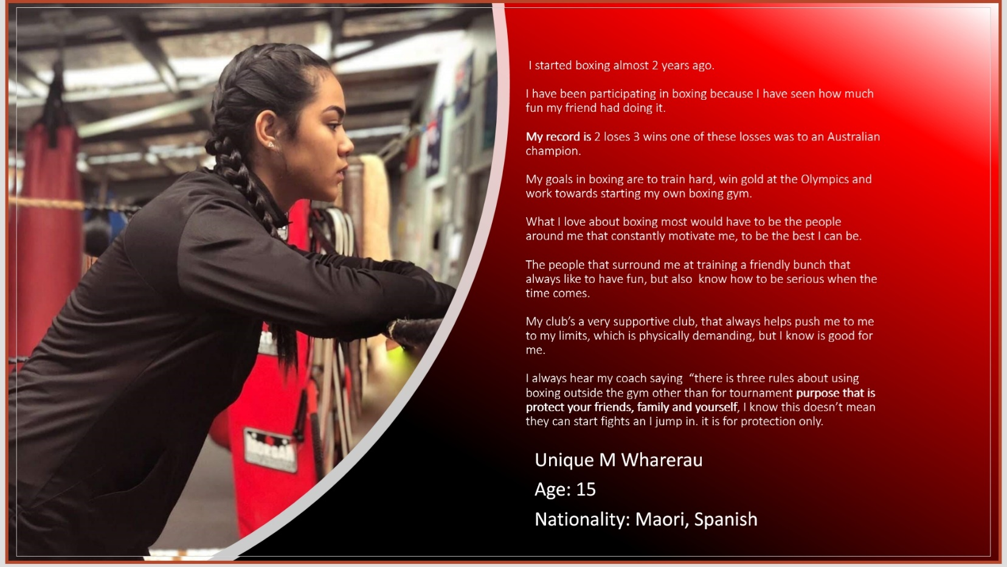
Boxer feature, stats and hobbies
PRESS RELEASE
Wednesday, 3 July 2019
______________________________________________________________________

Caboolture Sports Club awarded 2019 Club of the Year!

Caboolture Sports Club took out the prestigious Club of the Year award at the Keno & Clubs Queensland Awards for Excellence for 2019.

The award, sponsored by Keno, recognises the community club that has delivered consistent, outstanding service and facilities to promote their objectives, and provide the highest level of social and entertainment facilities for their members and the community. Caboolture Sports Club delivers that in spades.

The Club has maintained a very high commitment to sports in the area, supporting its six (6) foundation sports clubs with over 3,100 playing members, including 1,454 junior players.

This, coupled with a further 375 community grants, provided a total of $1,783,174 in cash & in-kind community support during the last financial year alone.

In addition to winning Club of the Year, Caboolture Sports Club also took out the categories of Best Multi-Sport Club, Best Club Redevelopment under $2million, Best Club North Brisbane, and Best Entertainment Venue.

Caboolture Sports Club CEO Kelvin Patch said that the Club of the Year award came as “a welcome surprise”, and was an achievement that is shared with the board, staff and 75,000 members of the Club.

The Club boasts over three dining areas, free live entertainment six times a week, and function spaces to suit any occasion; there is something for everyone to enjoy including the kids.

Members can even dine in peace whilst the kids get crafty in the Explorer’s Kids Club or play on the outdoor playground fully supervised.

Stay up to date with what’s on at Caboolture Sports Club by following the Club on social media @cabsports or visit cabsports.com.au for more information.

Thank you

Spiders Boxing Club would like to say a huge thank you to all of the sponsors and volunteers that are making our 2019 Annual Boxing Tournament a smooth running success and we hope to see you all on the 27th July.

Reminder:

First Aid Course- On the 31st August 2019, Spiders Boxing Club, 2 Toovey St, Caboolture QLD 4510 will be holding a first aid course upstairs for all who may be interested. Depending on the amount of people who attend this course it will be around $80 for the full first aid certificate or $50 to receive your CPR certification. Please let admin know if you would like to take part in this opportunity.

Congratulations to the following committee who were elected at our AGM:
We still have some vacancies, if you are interested please see any of the management committee

Management Committee
President – Kylie Burford
Vice President – Paul Stenning
Treasurer – Trudy Logan
Secretary – Krys Hapgood
Policy Officer – Paul Stenning
Senior Coach – Luke Sheehan
Senior Committee – Position Vacant
HR Consultant- Kyra Patterson

Committee Members
MPIO Officer – Position Vacant
Publicity Officer – Paul Stenning
Sponsorship Officer – Ben Hussain
Fundraising Officer – Krys Hapgood
Grant Officer – Lee-Anne Hunter
Newsletter Officer – Briannah Cleghorn
Tournament Coordinator / Assistant – Krys Hapgood
Junior Members – Halen Burnham, Unique Wharerau, Connor Dippelsmann and Malachi Wharerau.
General Members – Lindsay Dullaway
Front Desk – Briannah Cleghorn
Coaches –John Sparks, Ryan Wharerau and Rosa Wharerau
Assistant Coaches – Halen Burnham

